Non-blocking techniques
Non-blocking techniques in JavaScript are essential for creating efficient and responsive applications, especially in environments like web browsers where UI responsiveness is critical. Here are some common non-blocking techniques used in JavaScript:
1. Callbacks
Callbacks are functions passed as arguments to other functions and are invoked after the completion of an asynchronous operation.
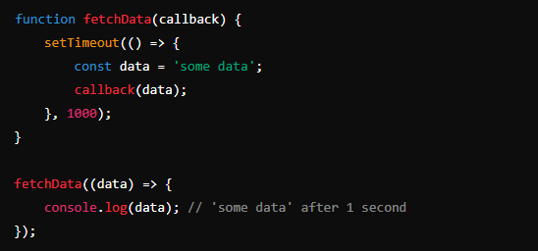
2. Promises
Promises represent the eventual completion (or failure) of an asynchronous operation and its resulting value.
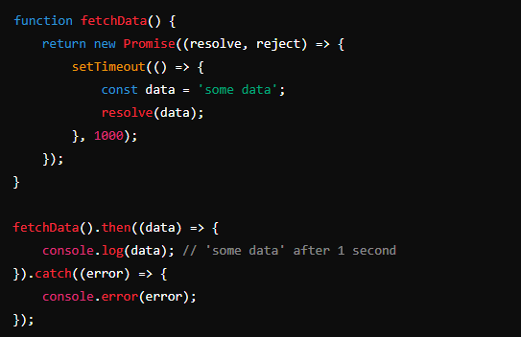
3. Async/Await
async and await are syntactic sugar built on top of Promises, making asynchronous code look and behave more like synchronous code.
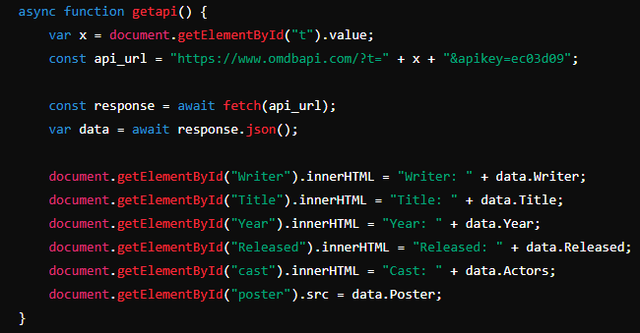
4. Event Loop and Event Handling
JavaScript's event loop allows for non-blocking I/O by handling events and executing callback functions when an event occurs.
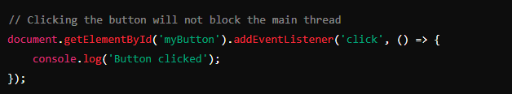
5. Web Workers
Web Workers run scripts in background threads, allowing you to perform computations without blocking the main thread.
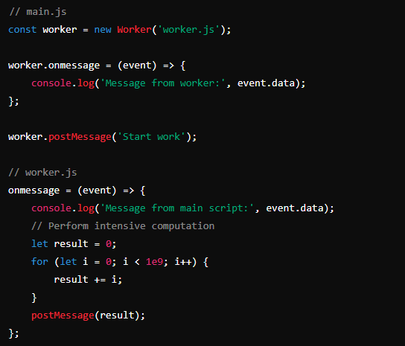
6. Timers
Using setTimeout and setInterval allows you to delay code execution, thus not blocking the main thread.
